**NCTU 2019 CV HW5:**

**Structure from Motion (SfM)**

**Hsin-Yu Chen, Yuan-Syun Ye**

**May 2019**

**1 Introduction**

In this homework, we need to builds a classifier to categorize images into one of 15 scene types. We must complete the task by three ways:

1. Tiny images representation + nearest neighbor classiﬁer
2. Bag of SIFT representation + nearest neighbor classiﬁer
3. Bag of SIFT representation + linear SVM classiﬁer

That is, we need to Implementation two kinds of images representation with knn classiﬁer and linear SVM classiﬁer.

Also, we tried standard CNN model and ResNet with pre-train model to classify the images.

We Implement task1 and task2 in both MATLAB and python, and task3 in MATLAB.

**2 Implementation**

**2.1 images representation**

**2.1.1 Tiny images representation**

In Tiny images representation, all we need to do is resize the image to 16*16.

Then because we need to compute the distance for nearest neighbor classiﬁer, we reshape the image into shape 1*256

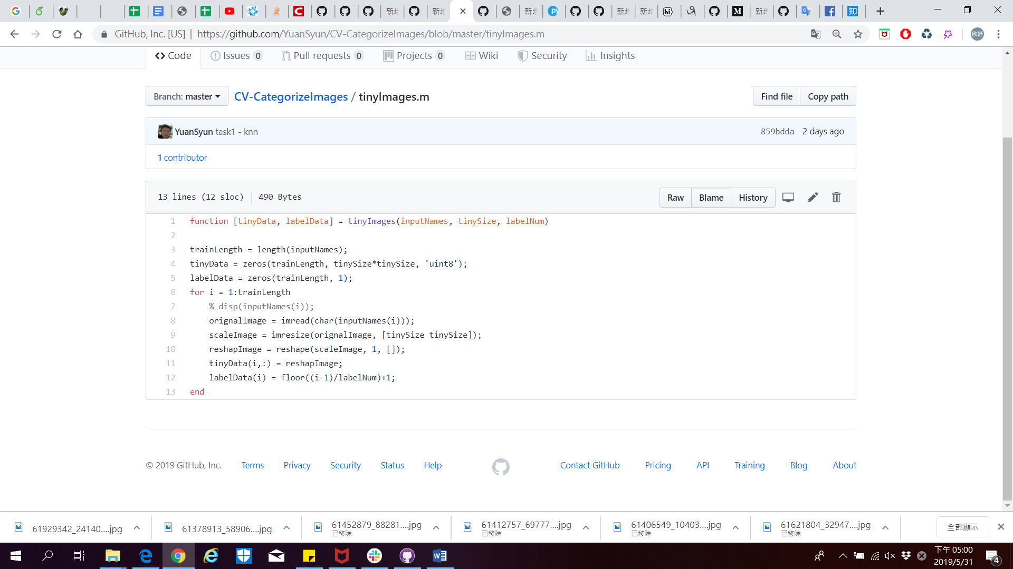

**🡺** **Implementation by MATLAB**

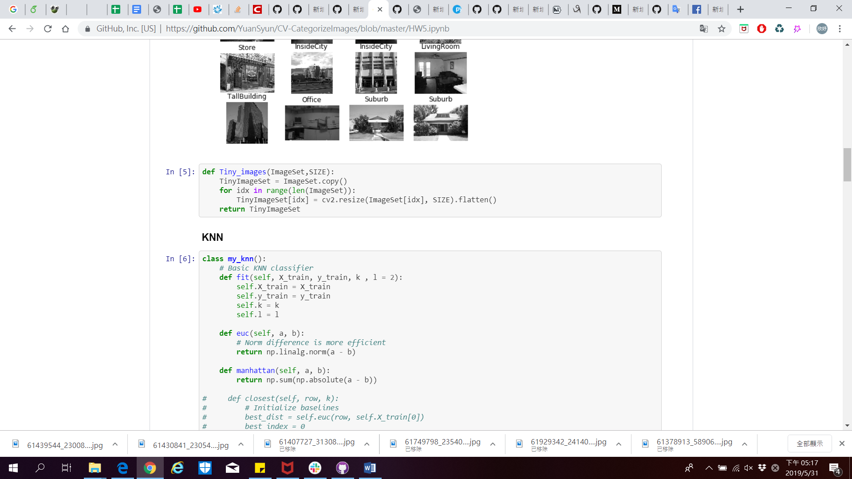

**🡺 Implementation by python**

**2.1.1 Bag of SIFT representation**

We use SIFT to find the descriptors for each image, then stack all the descriptors in a numpy array.

Then we do k-means clustering to find out k clustering center from all the descriptors, where we set k = 300.

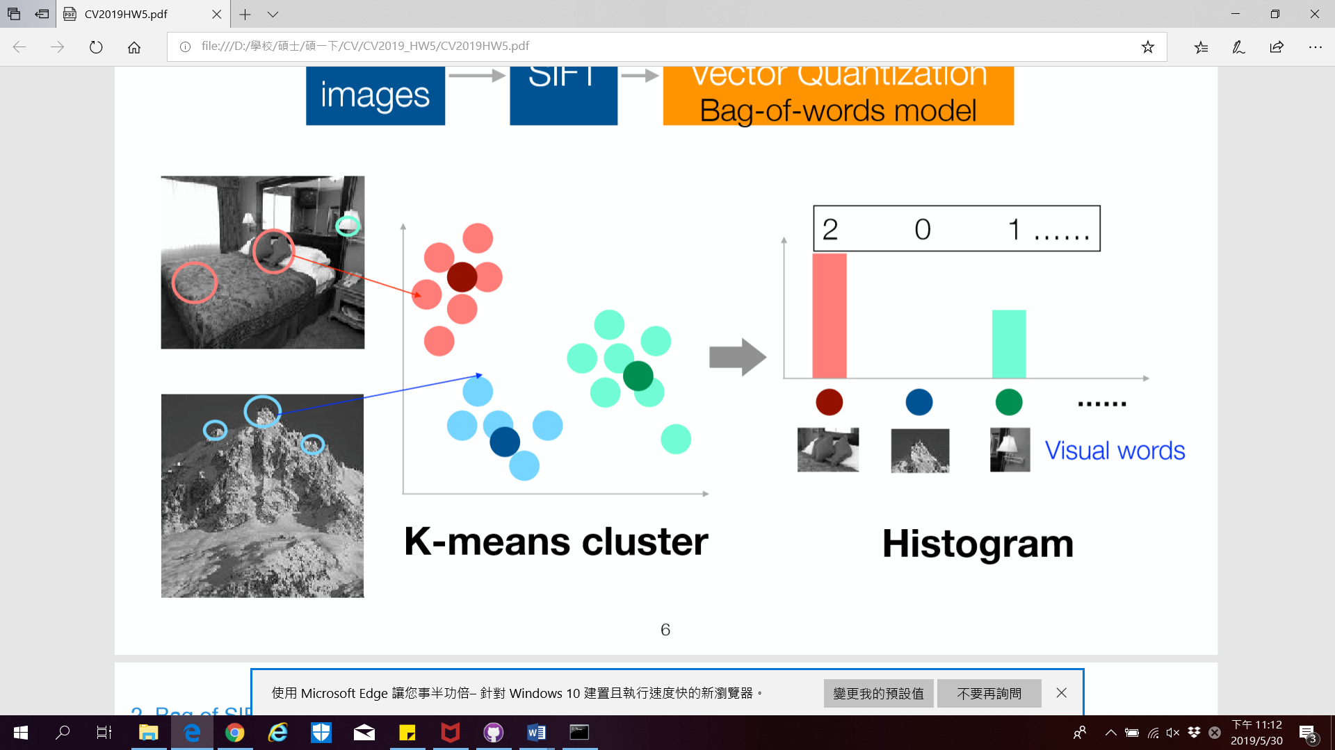

🡺Find k clustering center

Next, we classify features of each image and calculate the histogram of them. Then the histogram is the Bag of SIFT representation of the image.

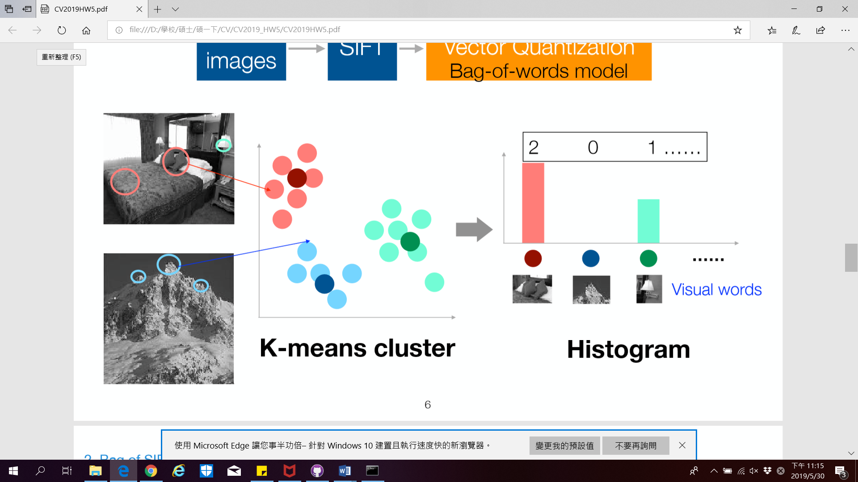 

🡺 Calculate the histogram of image features

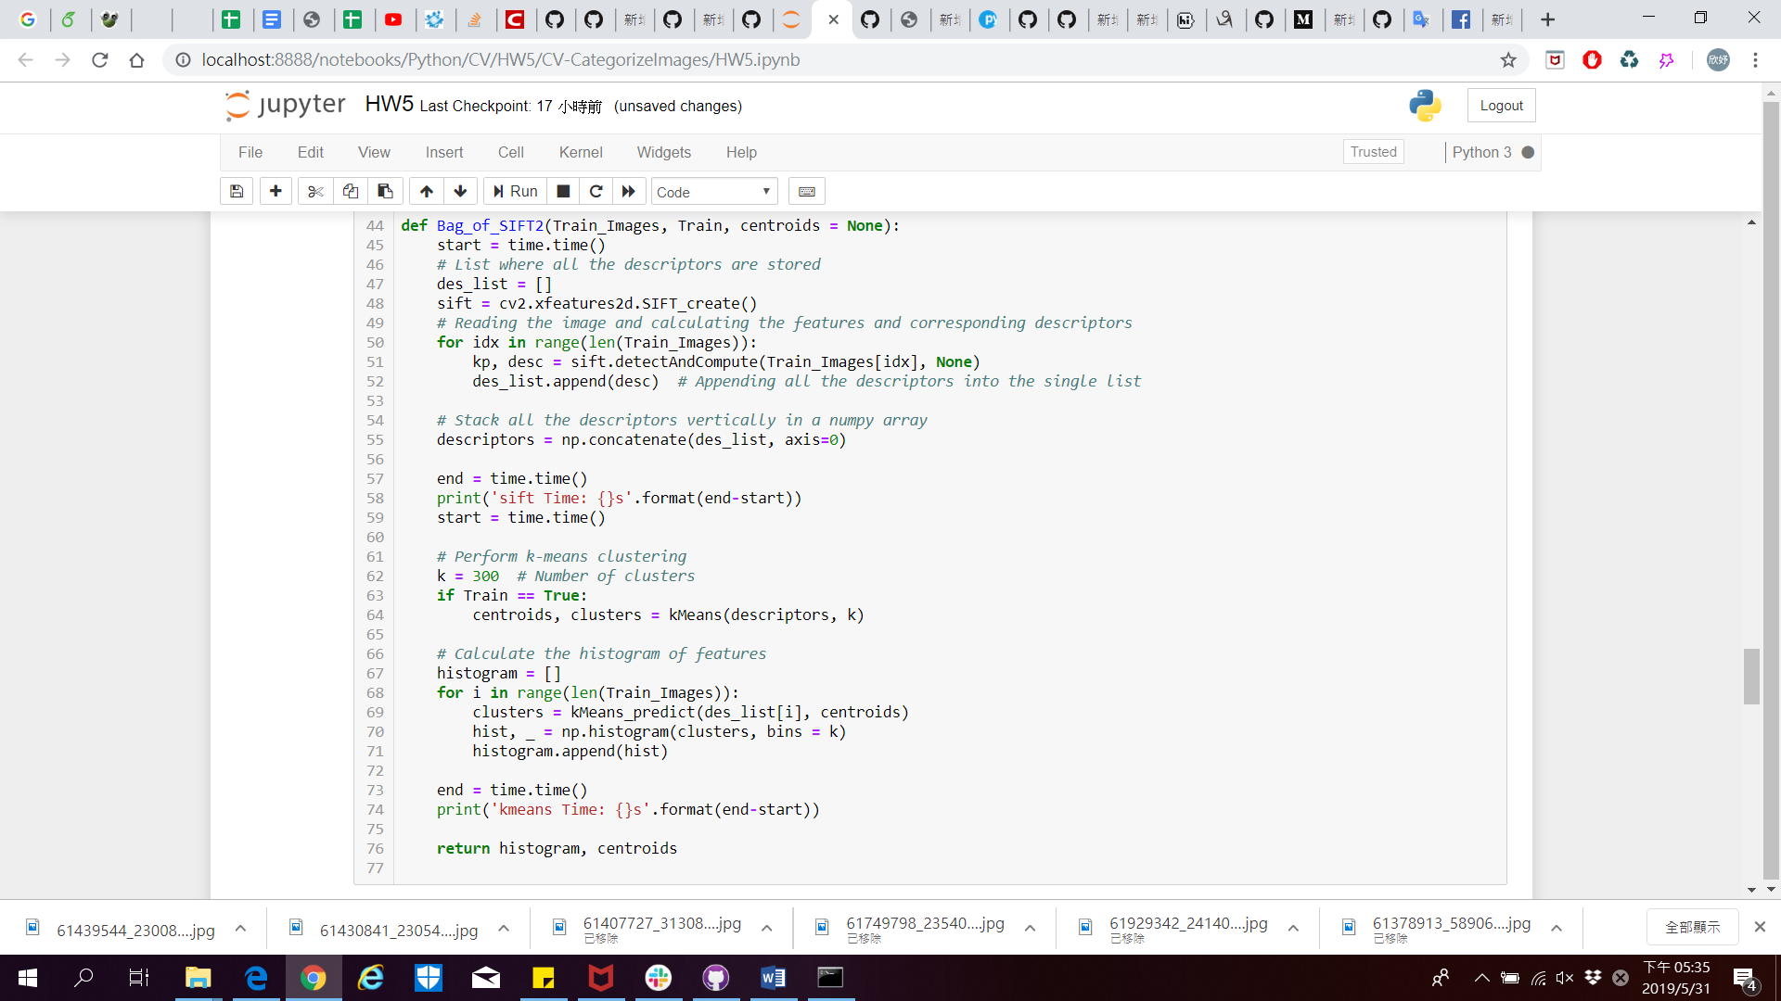

**2.2 Classiﬁer**

**2.2.1** **Nearest neighbor classiﬁer**

We Implementation both Euclidean distance and Manhattan distance to compute distance between the test image and each training data.

Euclidean distance 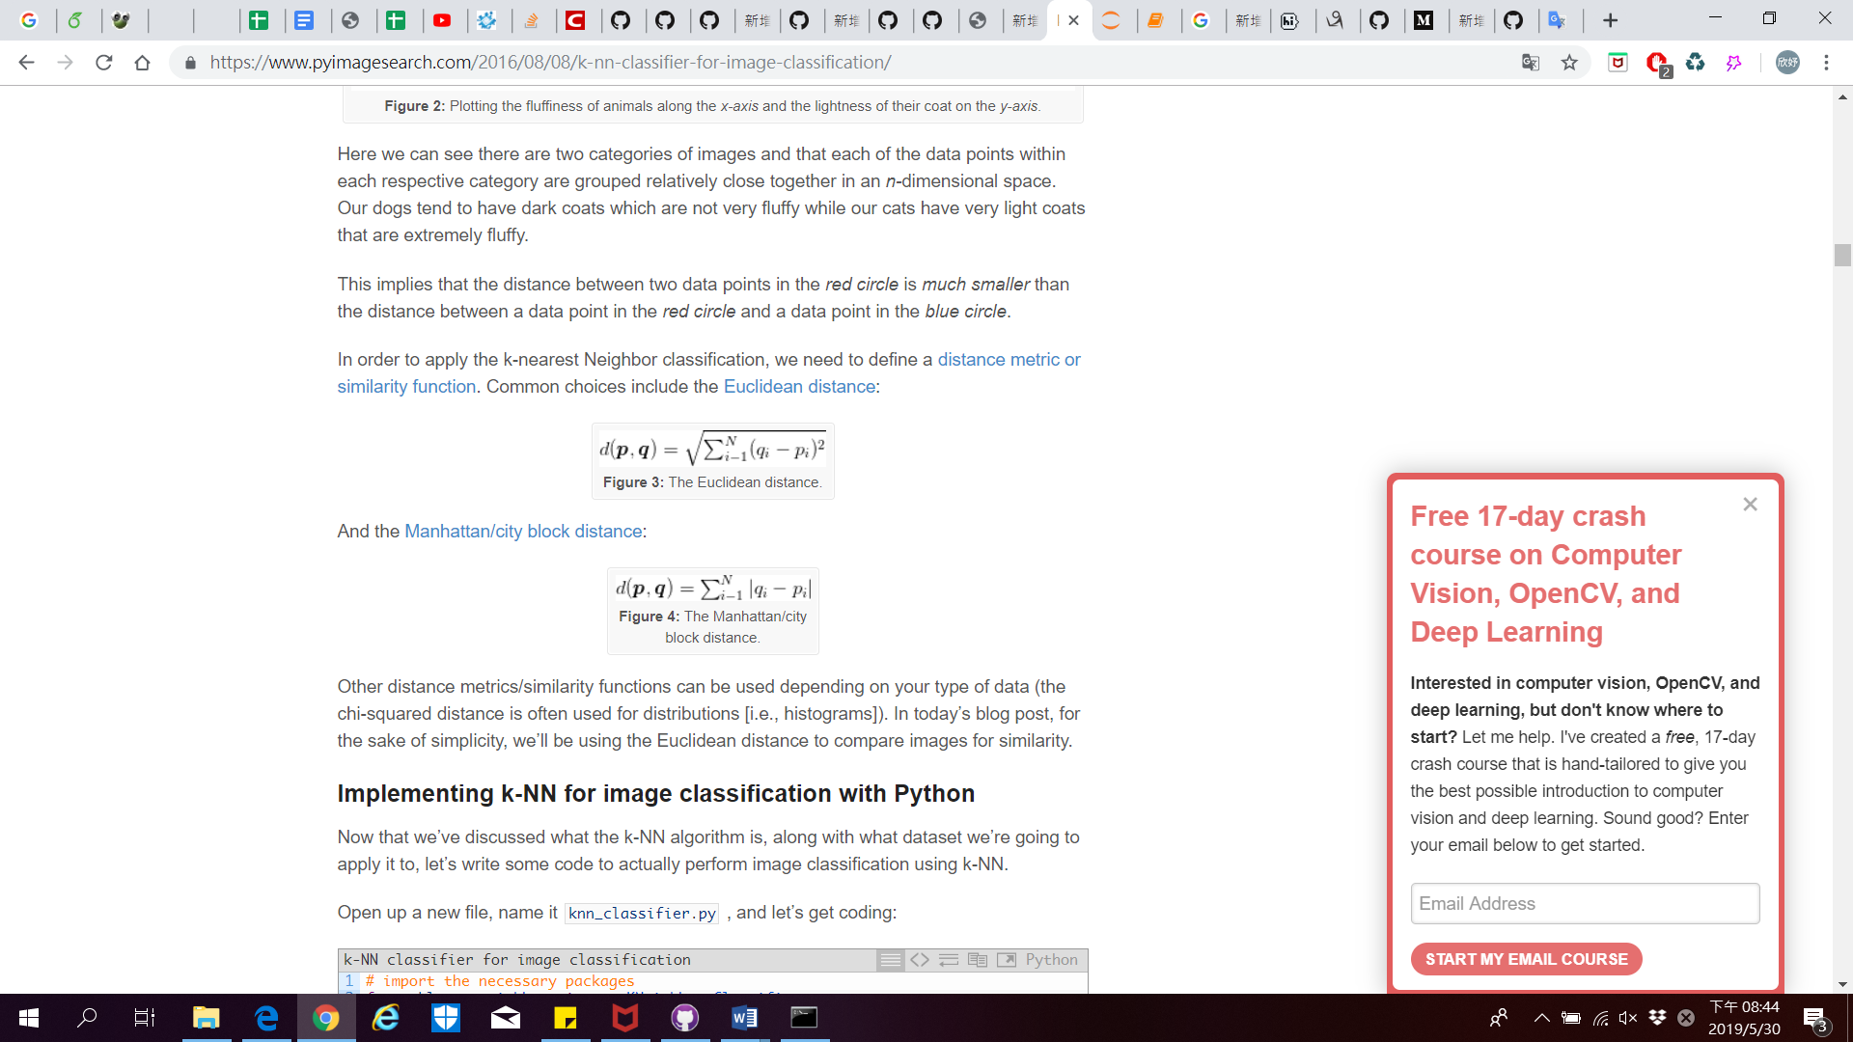

Manhattan distance 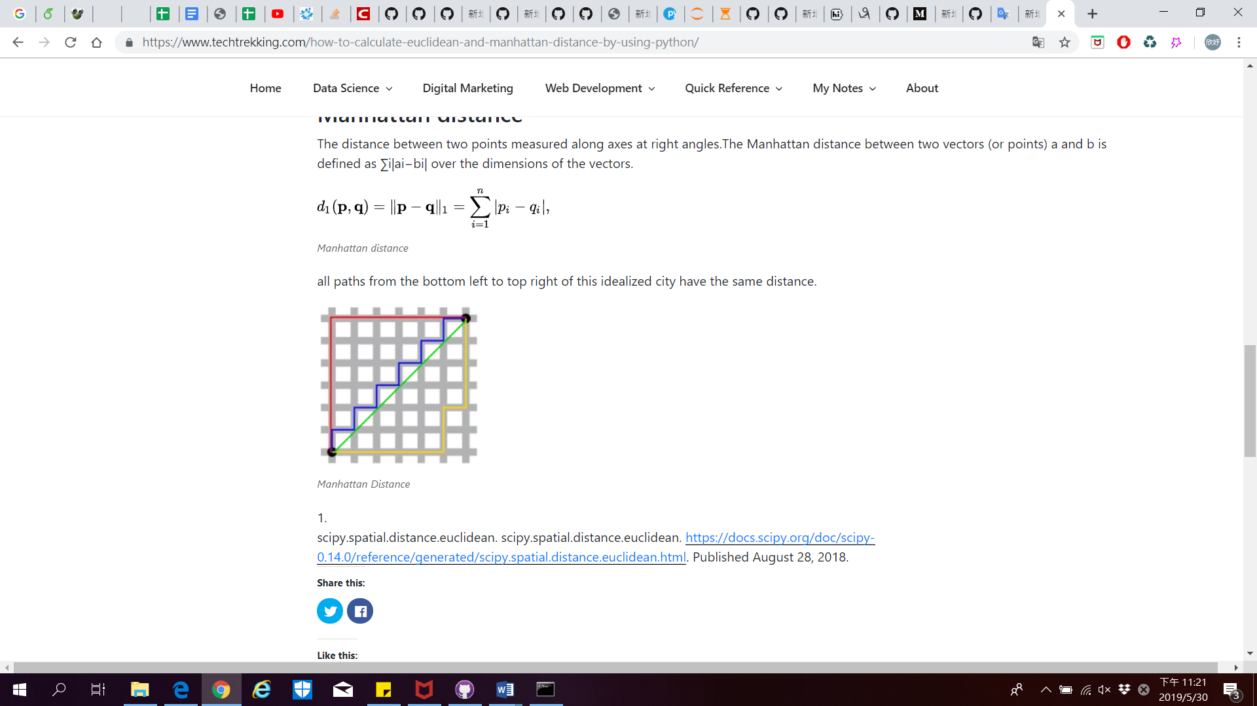

Then setting the label of test image as same as the training data which has shortest distance with the test image.

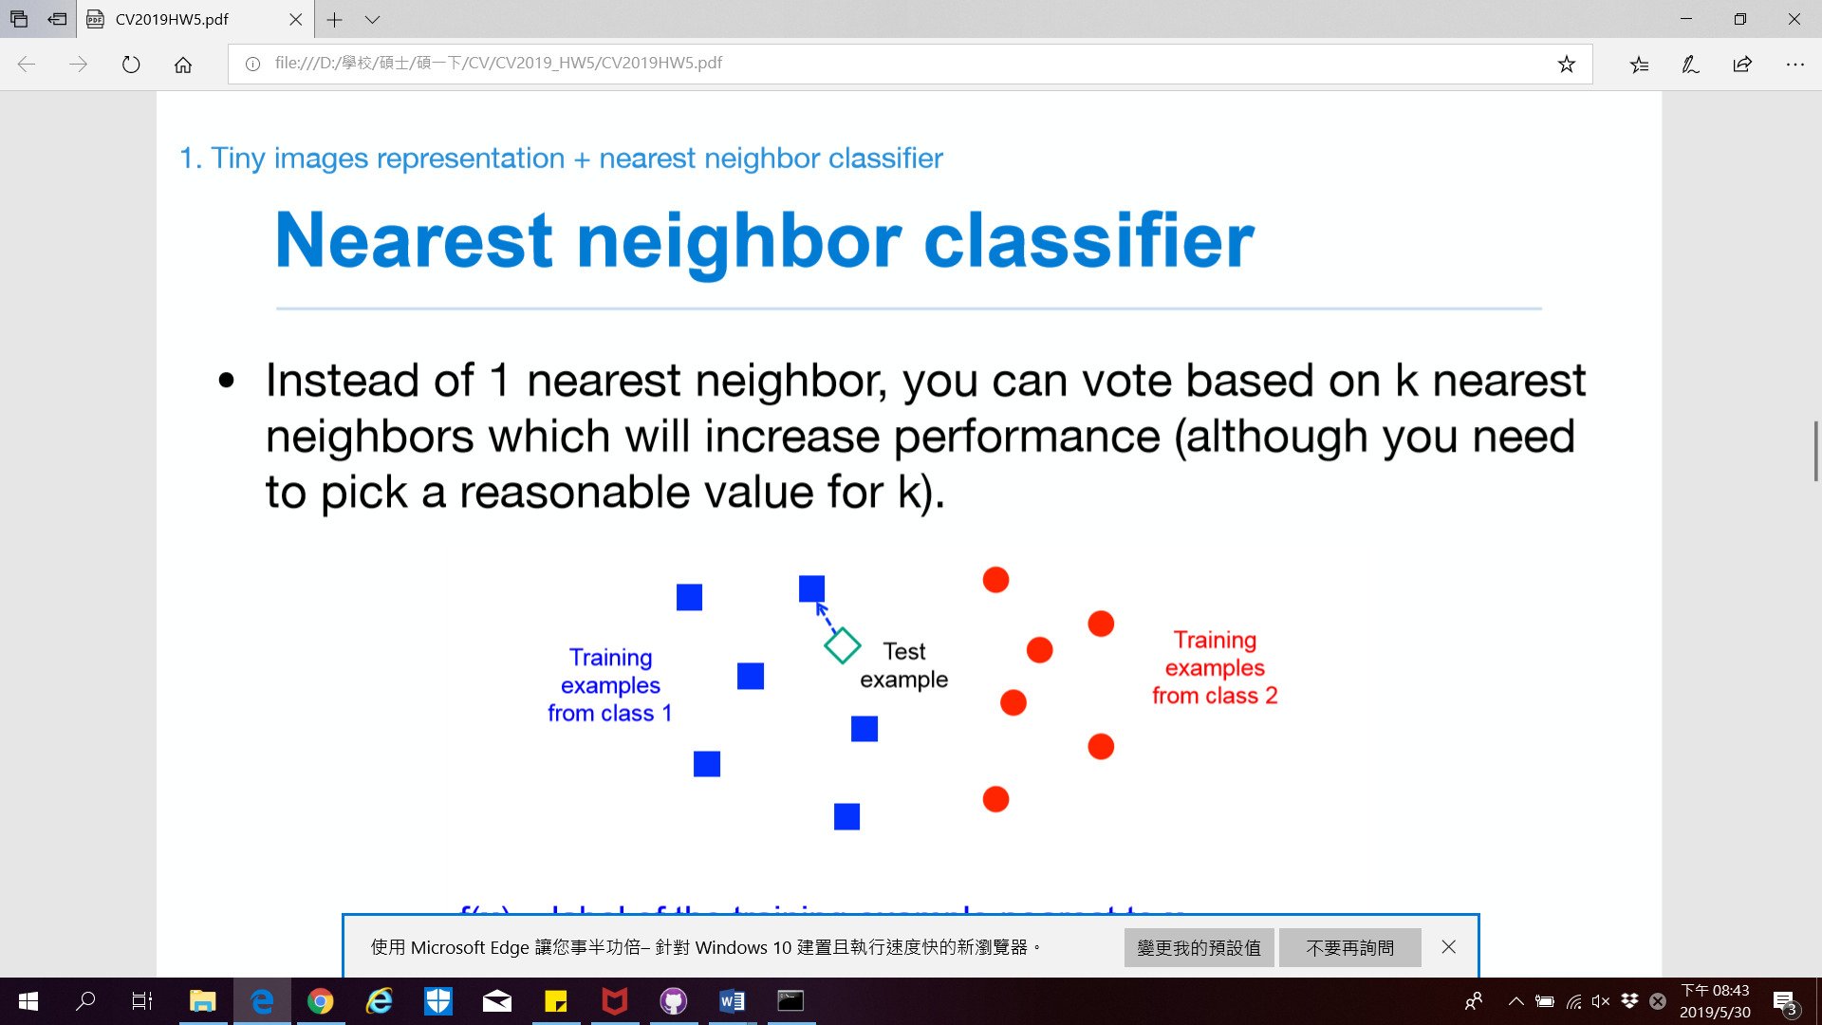

🡺 Set the test example label to class one

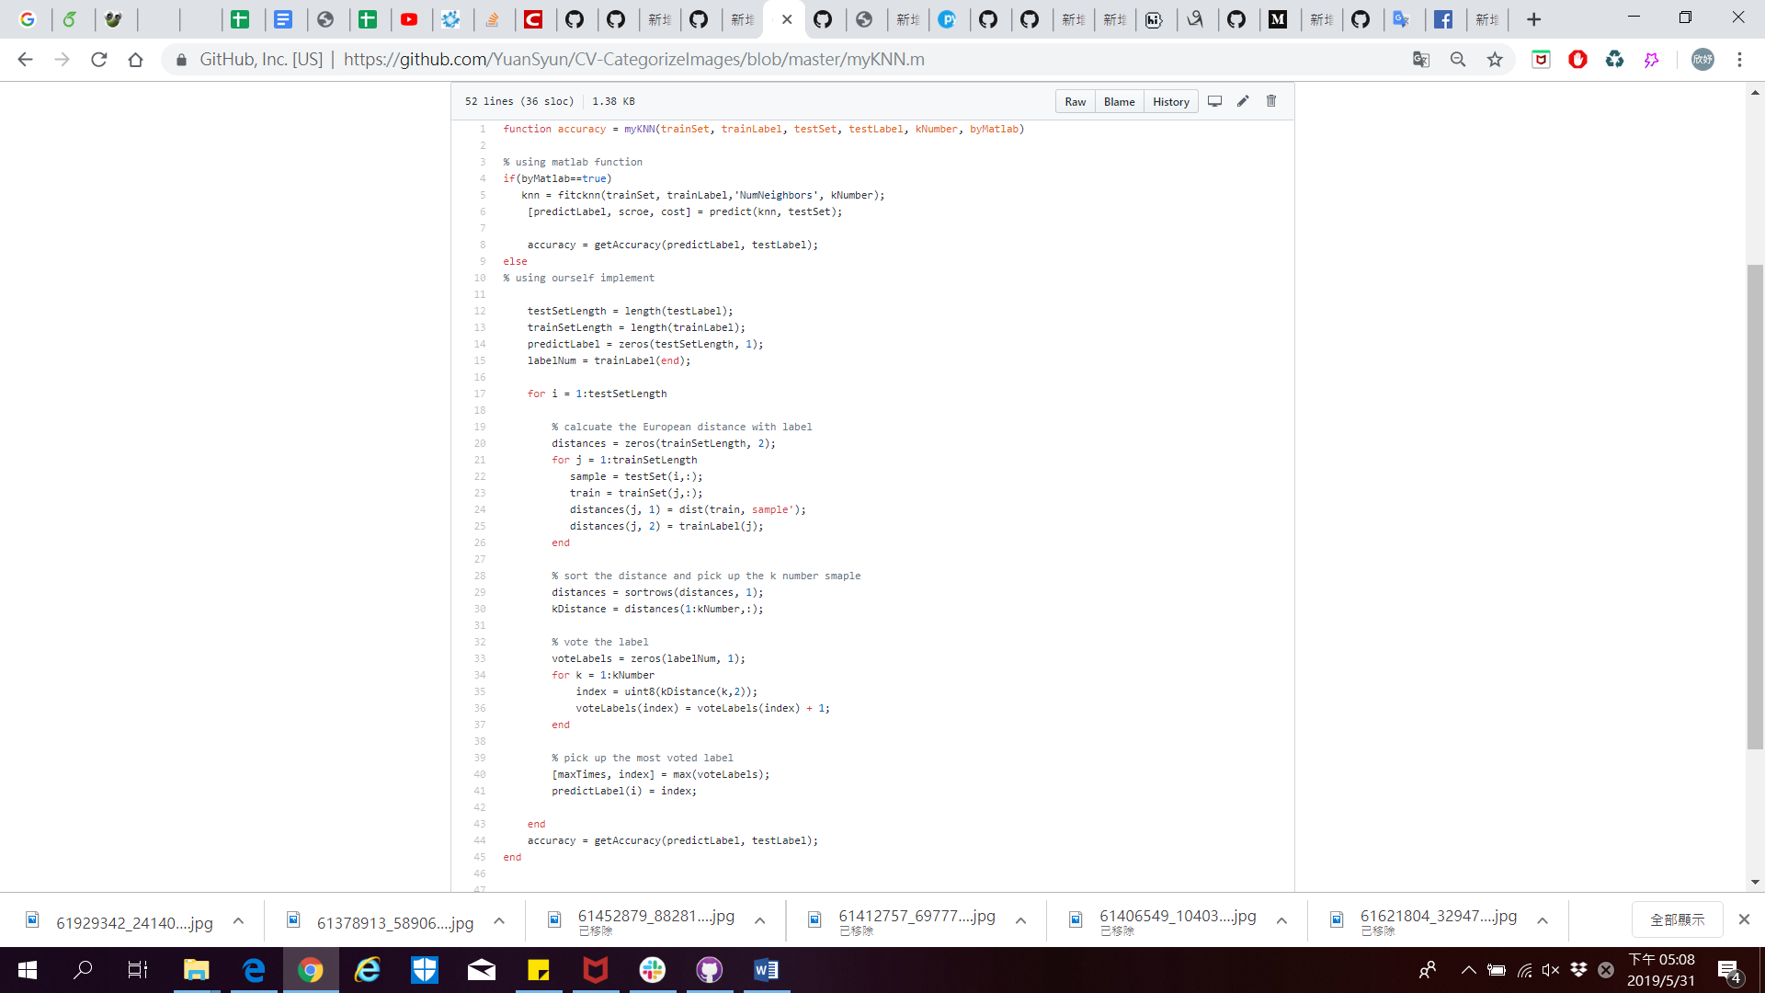

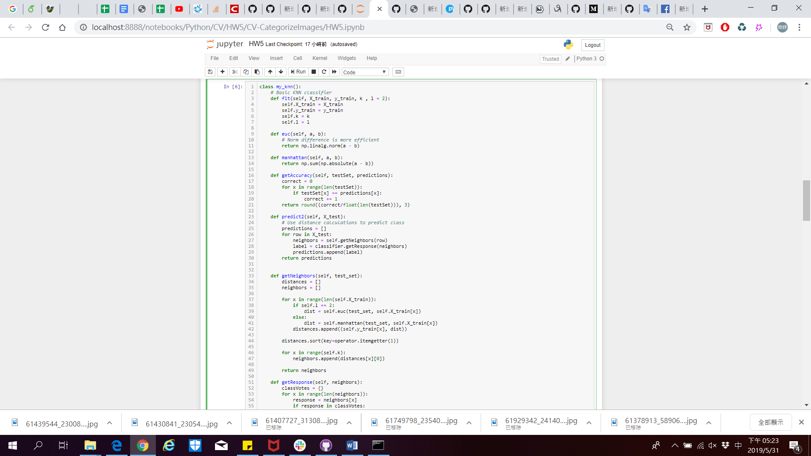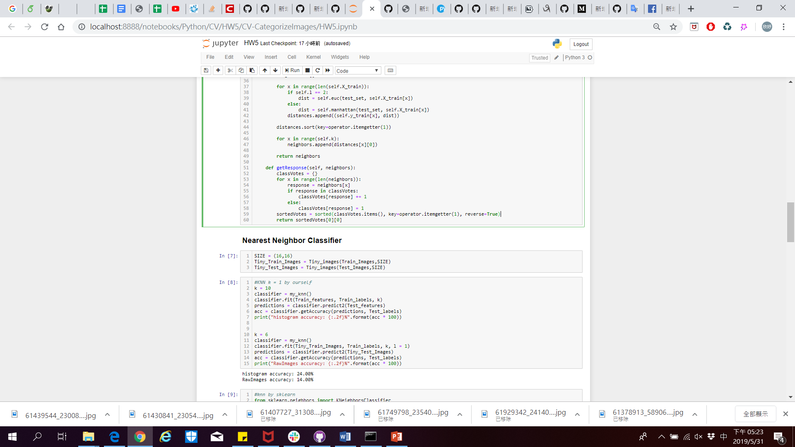

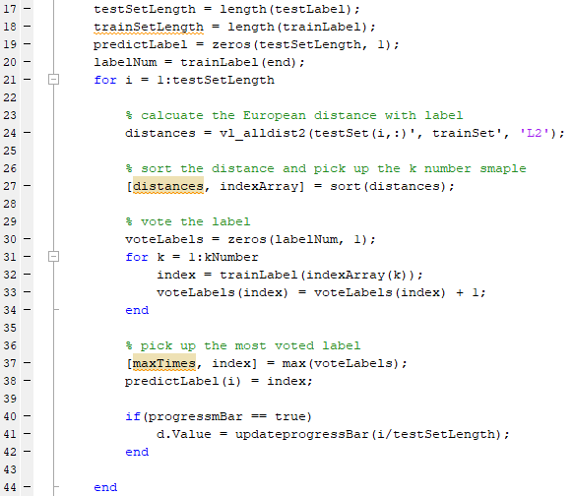

Figure 1 Nearest Neighbor Classifier (Matlab Code)

**2.2.2 Linear SVM classiﬁer**

**2.3 Deep Learning**

**2.3.1 Standard CNN model**

We use 2 layer CNN model with Adam as optimizer, and Cross Entropy as loss function to train the model.

**2.2.2 Pre-train ResNet model**

Because the training dataset are too small and the accuracy doesn’t seem good, we constructs a pre-train ResNet-34 model. The model has four layers with Adam as optimizer, and Cross Entropy as loss function.

**3 Experimental**

**3.1 Tiny images representation + nearest neighbor classiﬁer**

Accuracy: 21.5%(k=5, L1 Distance), 18.5%(k=5, L2 Distance), 18.5%(Matlab function)

|  |  |  |
| --- | --- | --- |
| Figure L1 distance | Figure L2 distance | Figure Matlab function |

**3.2 Bag of SIFT representation + nearest neighbor classiﬁer**

Accuracy: 8.5%

|  |  |  |
| --- | --- | --- |
| Figure SIFT Features |  | Figure using Matlab KNN |

**3.3 Bag of SIFT representation + linear SVM classiﬁer**

Accuracy: %

**3.4 Deep Learning by standard CNN model**

Accuracy: 30-35%

Because the training dataset are too small and the accuracy doesn’t seem good

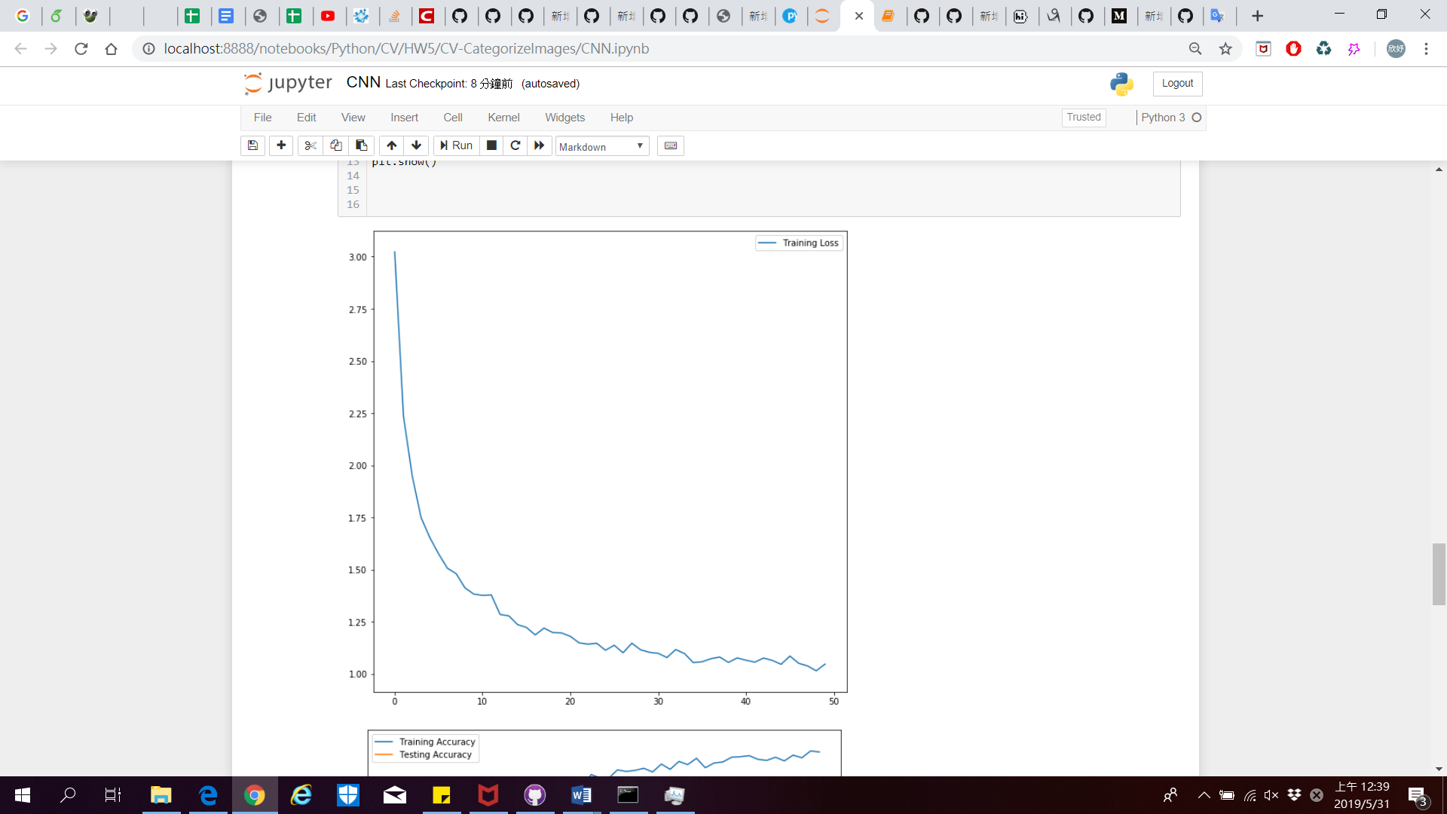

🡺 Training Loss

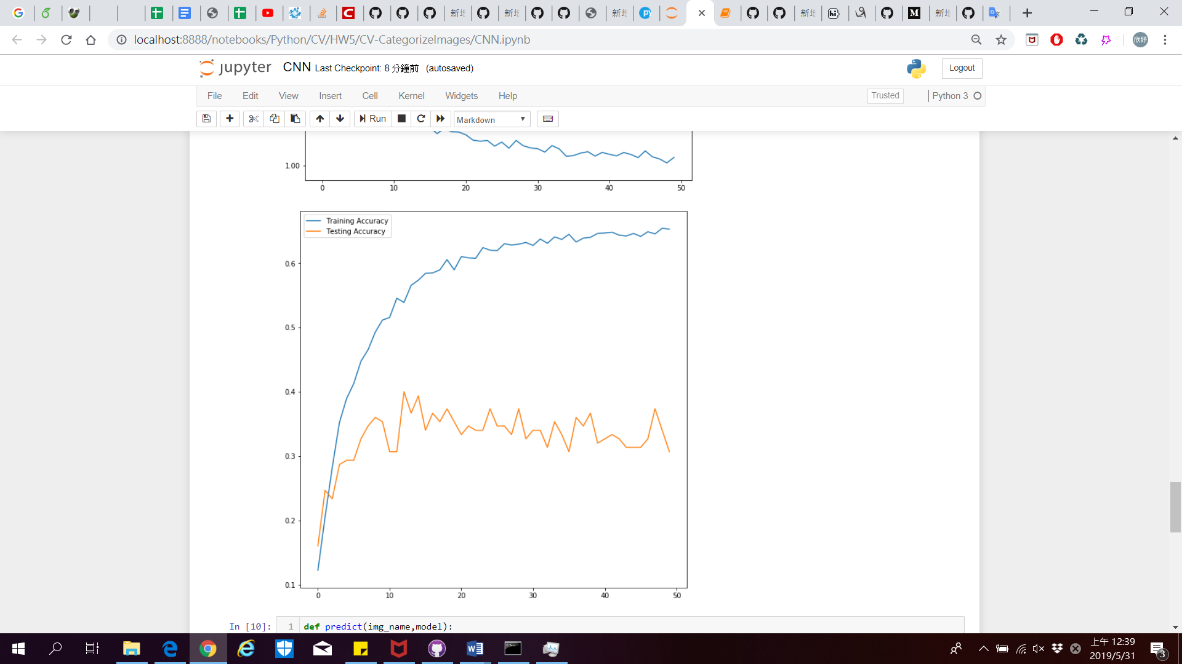

🡺 Training Accuracy & Test Accuracy

**3.5 Deep Learning by pre-train ResNet model**

Accuracy: 75-80%

Due to the limitation of GPU memory size, we only run 10 epoch. But because we use the pre-train model, that has a good test accuracy.

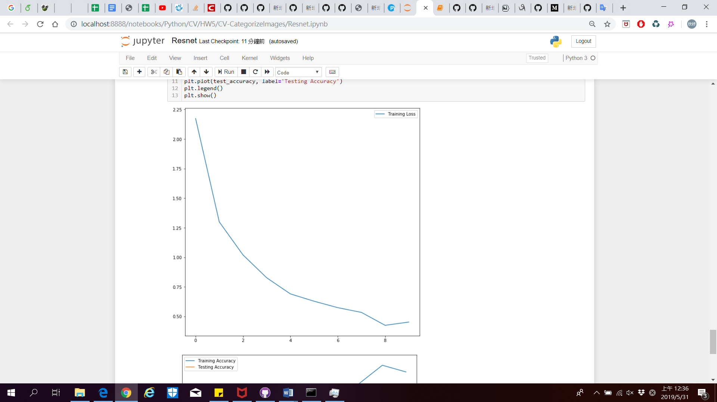

🡺 Training Loss

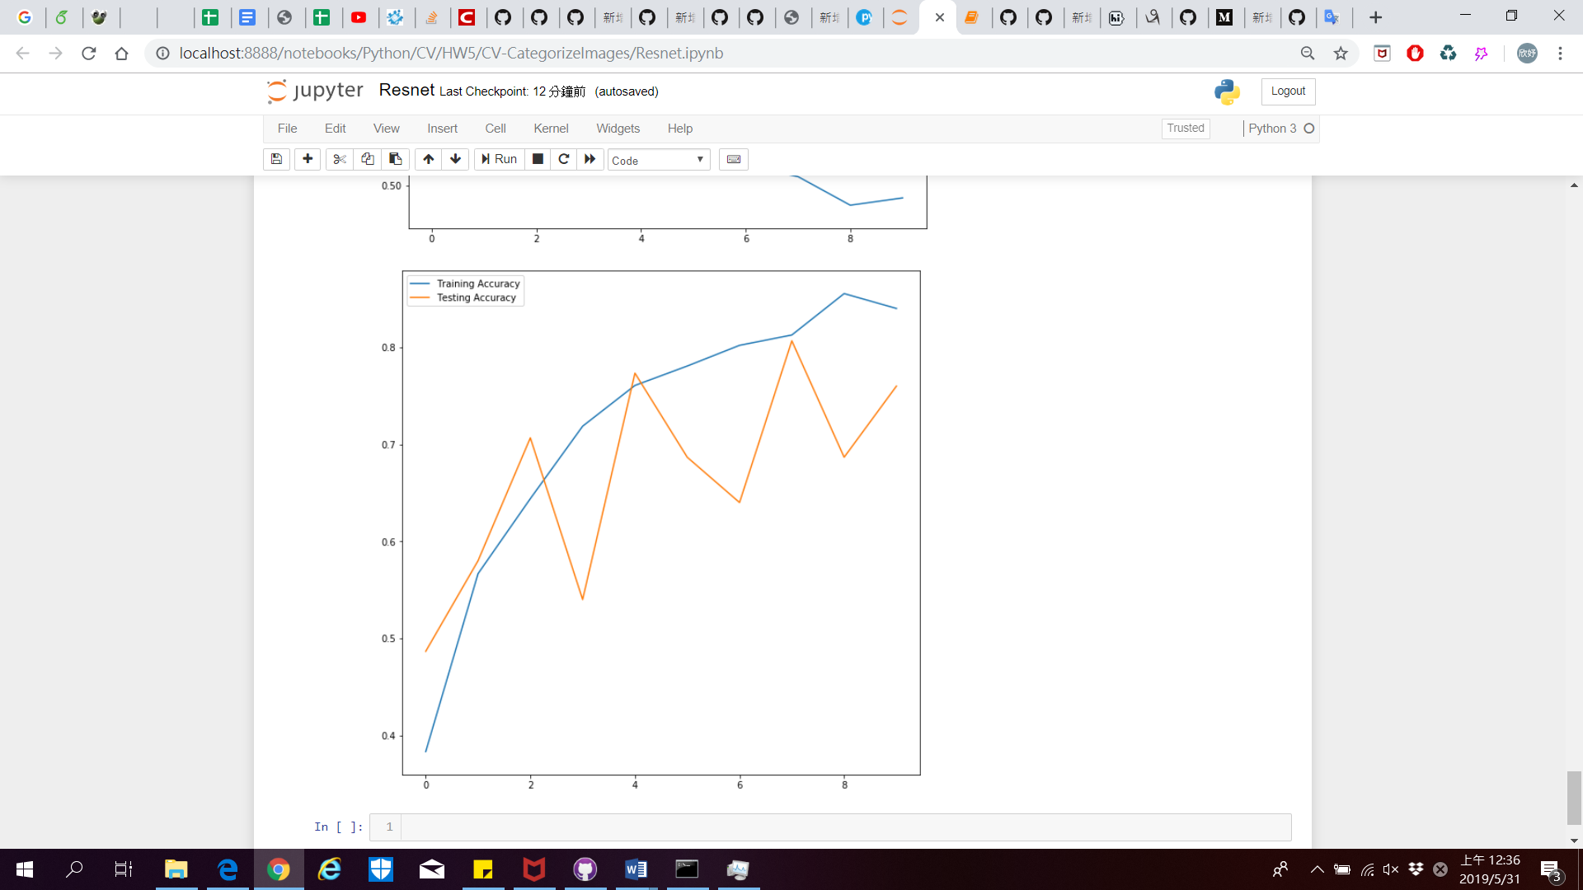

🡺 Training Accuracy & Test Accuracy

**4 Discussion**

In task1, Tiny images representation + nearest neighbor classiﬁer, we found out that when compute distance between the test image and each training data, accuracy of Manhattan distance is better than Euclidean distance. That may because gray value of Tiny image is between 0 to 255, and if we used Euclidean distance, the distance would become large for some extreme case which may Influence the result.

**5 Conclusion**

We Implement image classifier in two different ways with two kind of image representation. And we also Implement two deep learning model, CNN and ResNet.

Then we show the accuracy in each task and the value of k for knn classiﬁer.

**6 Work Assignment Plan**

This homework divided into two parts. Yuan-Syun Ye is responsible for the part of cording by MATLAB and checks this report. Hsin-Yu Chen is responsible for the part of cording by python and the writing of the report.

**References**

https://www.pyimagesearch.com/2016/08/08/k-nn-classifier-for-image-classification/